**Lab 5: *Hashes, Asymmetric Encryption & Digital Signatures* (2%)**

**Name: Khai Phan Student Number: 100901164**

**Results**

**Part 1: Create a Public Key**

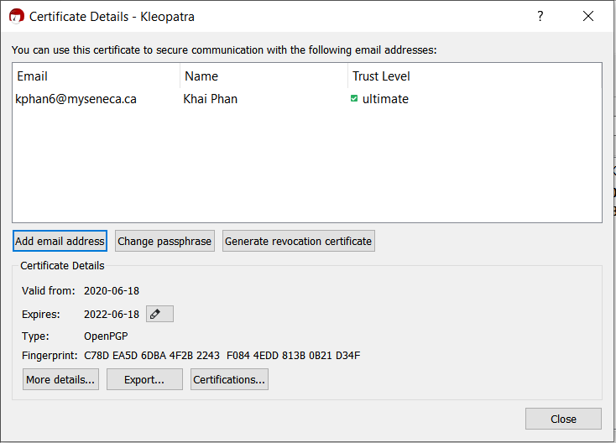

**Part 2: Received Public Key**

* **Marco’s Public Key Carlianz’s Public Key**

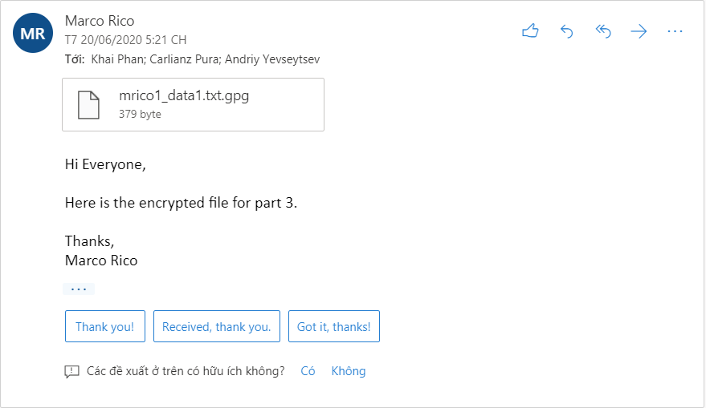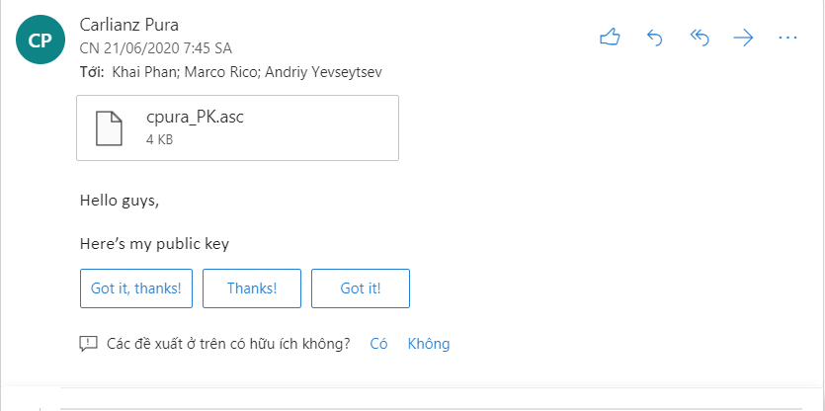

* Andriy’s Public Key

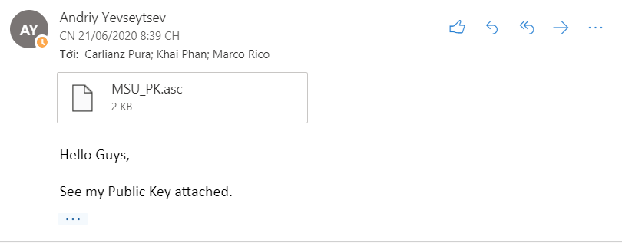

**Part** 3

* **Encrypting**

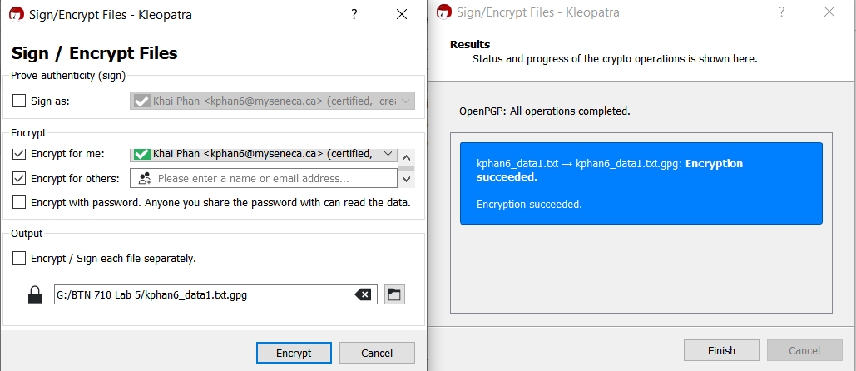

* **Decrypting**

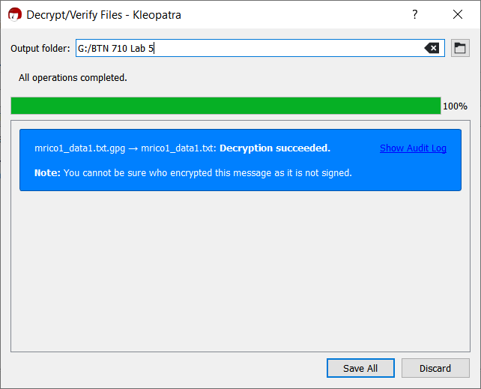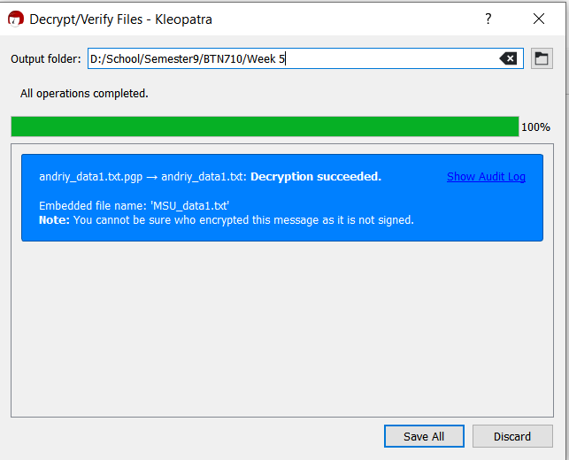

**Part 4**

* **Signing (mrico)**

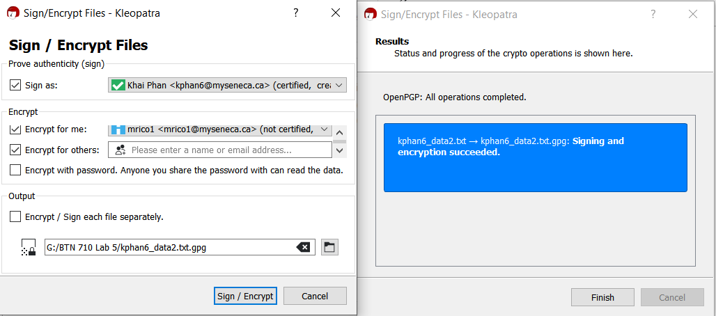

* **Signing (cpura)**

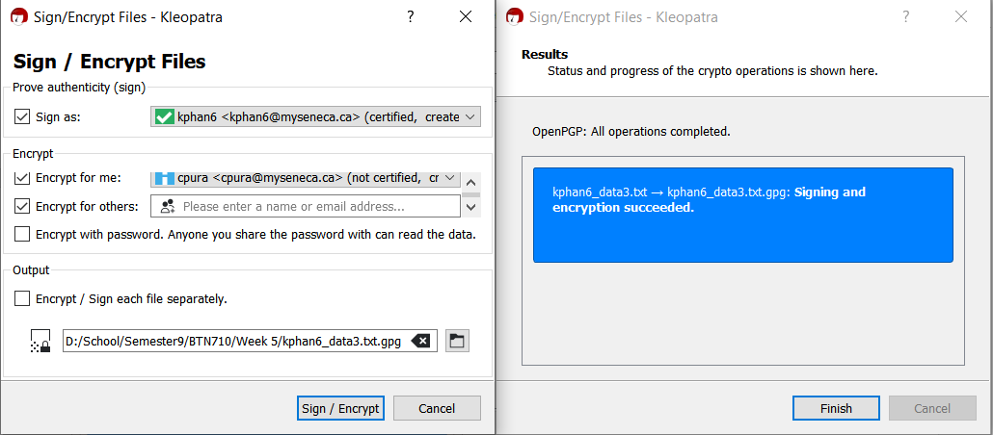

* Signing (andriy)

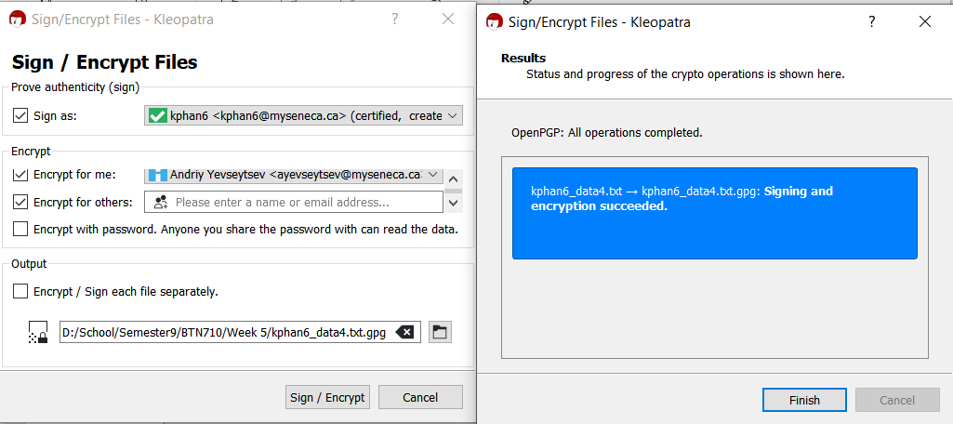

* Sent private key signed

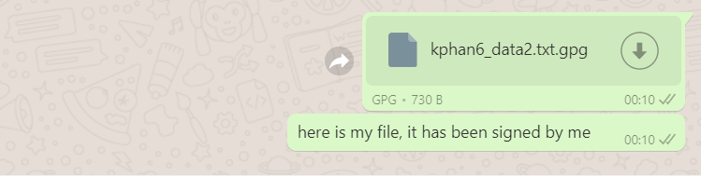

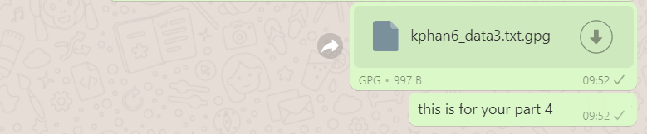

* **Signing (decryption)**

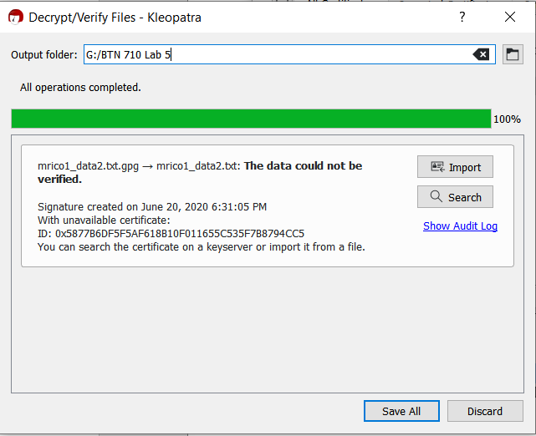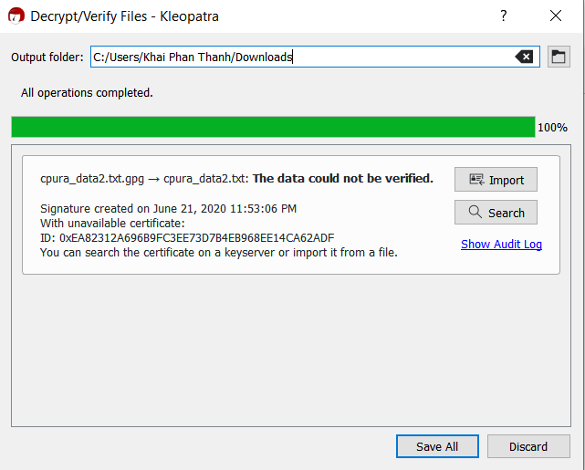

**Part 5**

* **Navid’s key**

**Part 6**

* **List files**
* 